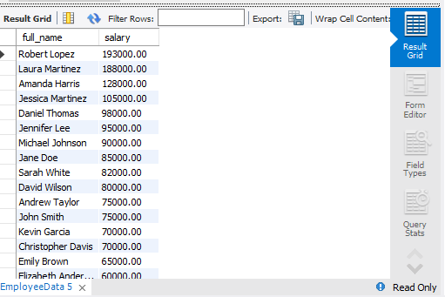

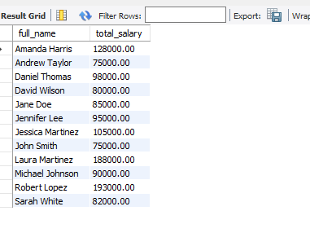

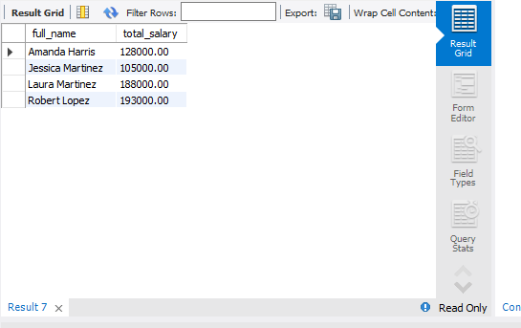

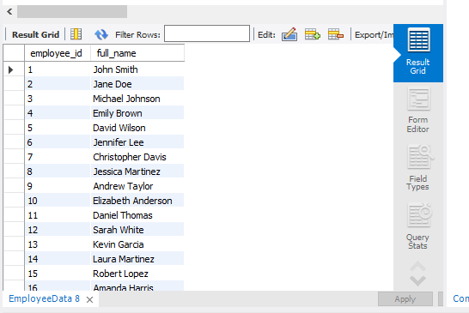

CREATE DATABASE employeeBD;

USE employeeBD;

CREATE TABLE EmployeeData (

employee_id INT AUTO_INCREMENT PRIMARY KEY,

full_name VARCHAR(100),

department VARCHAR(50),

salary DECIMAL(10,2),

hire_date DATE,

manager_id INT

);

INSERT INTO EmployeeData (full_name, department, salary, hire_date, manager_id) VALUES

('John Smith', 'Sales', 75000.00, '2017-05-15', NULL),

('Jane Doe', 'Marketing', 85000.00, '2018-03-20', NULL),

('Michael Johnson', 'Sales', 90000.00, '2016-08-10', 1),

('Emily Brown', 'HR', 65000.00, '2019-01-05', NULL),

('David Wilson', 'Marketing', 80000.00, '2017-10-25', 2),

('Jennifer Lee', 'IT', 95000.00, '2015-06-30', NULL),

('Christopher Davis', 'Sales', 70000.00, '2020-02-12', 3),

('Jessica Martinez', 'IT', 105000.00, '2014-09-18', 6),

('Andrew Taylor', 'Marketing', 75000.00, '2018-07-15', 2),

('Elizabeth Anderson', 'HR', 60000.00, '2020-04-01', 4),

('Daniel Thomas', 'IT', 98000.00, '2017-12-10', 6),

('Sarah White', 'Sales', 82000.00, '2019-08-05', 1),

('Kevin Garcia', 'HR', 70000.00, '2016-03-08', 5),

('Laura Martinez', 'Marketing', 188000.00, '2017-04-22', 4),

('Robert Lopez', 'IT', 193000.00, '2018-11-15', 9),

('Amanda Harris', 'Sales', 128000.00, '2018-09-30', 1);

SELECT full_name, salary

FROM EmployeeData

ORDER BY salary DESC;

SELECT full_name, SUM(salary) AS total_salary

FROM EmployeeData

GROUP BY full_name

HAVING SUM(salary) > 70000;

SELECT full_name, SUM(salary) AS total_salary

FROM EmployeeData

GROUP BY full_name

HAVING SUM(salary) > 100000;

SELECT employee_id, full_name

FROM EmployeeData;